
web development
Project proposal

August 31, 2026
Rosebank international
[Company address]

Mandilakhe Mfeti
St10531989
Group 1
Web Development (Introduction)
Project proposal
Part 1
Target organization: Mfeti Electrical Solutions (Pty) Ltd
(Hypothetical Business)

Table of content
Step 1…………………………………………….2
Step 2…………………………………………….3
Step 3………………………………………….....4
Step 4……………………………………………..5
Step 5……………………………………………..6
Step 6……………………………………………..7
Step 7……………………………………………..7
Step 8……………………………………………..7
Referencing list……………………………….8
Project proposal 2………………………….10

Part 1: Building the foundation
1. Organization Overview
Organization name
Mfeti Electrical Solution (Pty) Ltd

Brief History
Mfeti Electrical Solution is a small business that is offering electrical services to homes and businesses and this business is located in Gauteng in Midrand. This business was started by the Mfeti family in 2024. The business gets customers at the moment through word of mouth and also using social media like Facebook.


Mission
This is the goal helping the business to keep growing, by providing safe and affordable and quality electrical services while also giving customers excellent service.

Vision
To become one of the best and most trusted electrical companies in Gauteng.

Target audience
This website is for:
- Small businesses
- Homeowners
- Property managers
- Schools
- Churches
- Anyone looking for electrical services

2. Website goals and objectives
Website goals
- Is by helping more people find the business online.
- Also making it easy for customers to contact the business.
- It also helps customers to request for a quotation.
- Show the service that is offered by the business.
- Also building trust by showing customer reviews.
Key performance indicators (KPIs)
For the website to be successful it must:
- Get about 500 visitors every month.
- Also receiving at least 30 quote requests each month.
- And also bring more new customers.
- Helping customers to contact the business.
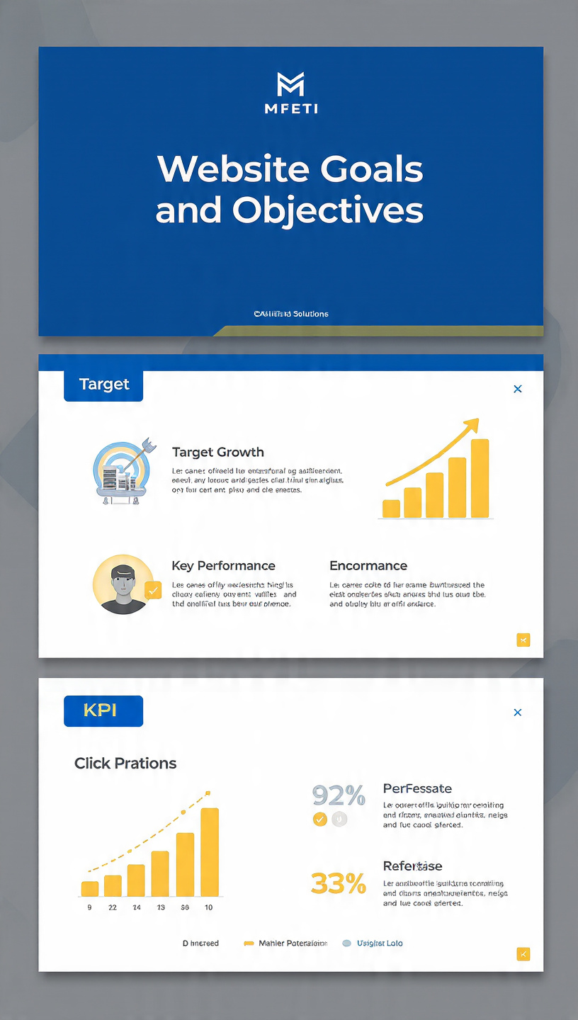

3. Current Website Analysis
Mfeti Electrical Solution does not have a website meaning there will be problems that will not help the business grow.
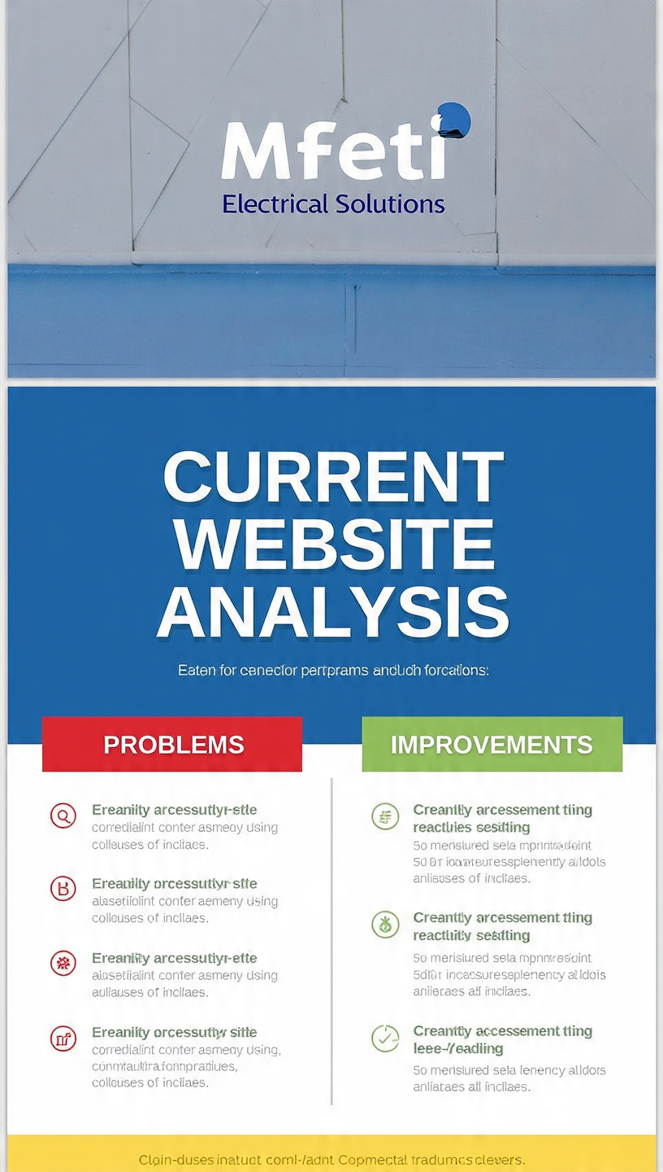
Problems
- This shows that customers will not be able to find the business online.
- Also meaning customers will not be able to request quotes online.
- The business will also not be able to show pictures of completed work.
- The marketing will be limited.

Improvements
This new website will include:
- Business information
- Contact page
- List of services
- Photo gallery
- Google Maps location
- Customer testimonials

4. Proposed Website features and functionality
A website has these pages:
- Home
- About us
- Services
- Gallery
- Testimonials
- Request a quote
- Contact us
Features
- Easy navigation
- Mobile-friendly design
- Google maps
- Contact form
- WhatsApp button
- Social media links
- Image gallery

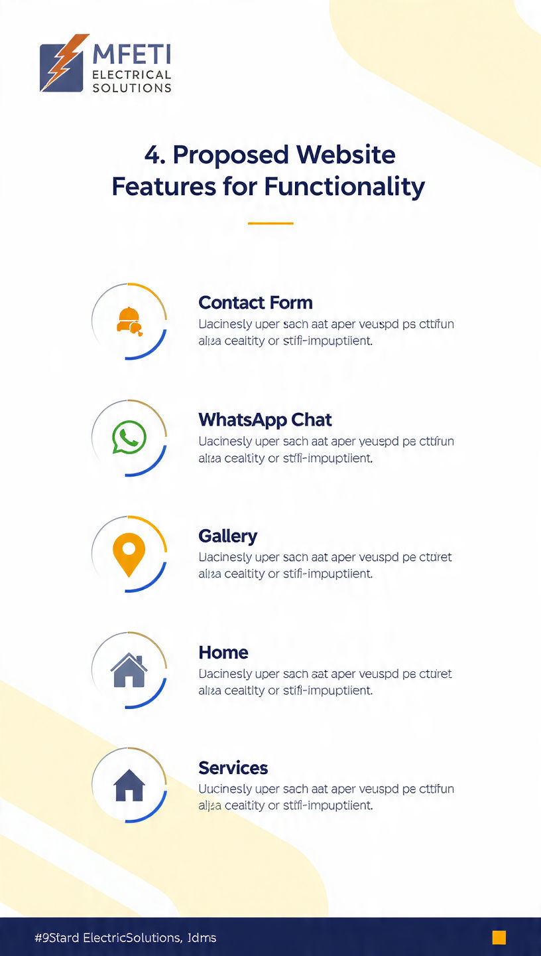

5. Design and user experience
The colors that will be provided is to make the website look professional and easy to read.
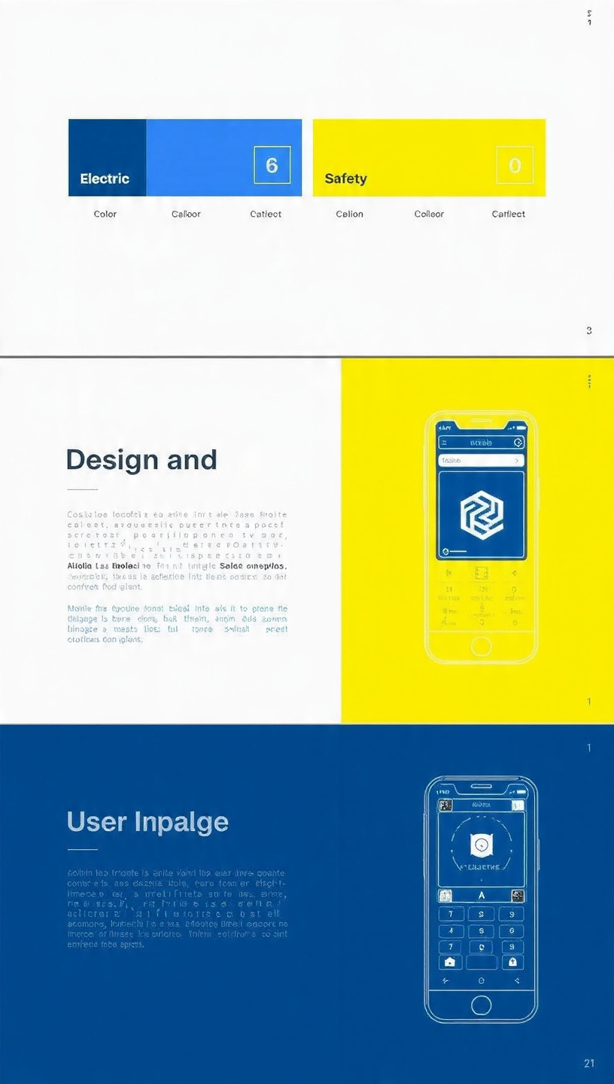
Color scheme
- Dark blue
- Yellow
- White
Font
- Headings: Poppins
- Body text: Arial
Layout
The website will have:
- A navigation menu at the top
- A large welcome banner
- Service sections
- Contact information at the bottom
6. User Experience
The website must and will:
- Be easy to use.
- Work on phones, tablets and computers.
- Load quickly.
- Also be easy to read.
Technical Requirements
Domain name
www.mfetielectrical.co.za
Hosting
Afrihost web hosting
Software and programming
- HTML
- CSS
- JavaScript
- Visual Studio code
- GiftHub

7. Timeline
Week | Task
1. | Research and planning must be done
2. | Create HTML pages
3. | Add CSS styling
4. | Make website responsive
5. | Add JavaScript
6. | Test the website
7. | Final changes and submission

8. Budget
Item | Cost
Domain name | R180
Hosting | R1 200
Website development | R8 000
Maintenance | R500 per month
Image | Free
Total | R9 380

References

Afrihost. 2026. Web Hosting. Available at: https://www.afrihost.com

Google. 2025. Google Maps Platform. Available at: https://developers.google.com/maps

MDN Web Docs. 2025. HTML: HyperText Markup Language. Available at: https://developer.mozilla.org/en-US/docs/Web/HTML

MDN Web Docs. 2025. CSS: Cascading Style Sheets. Available at: https://developer.mozilla.org/en-US/docs/Web/CSS

MDN Web Docs. 2025. JavaScript Guide. Available at: https://developer.mozilla.org/en-US/docs/Web/JavaScript/Guide (Accessed: 31 July 2026).

Website Project proposal 2
Target Organization: Mfeti Tech solution

1. Organization Overview
NAME: Mfeti Tech Solutions

History:
Mfeti Tech Solution is a small business started by Thando Mfeti to repairs laptops, desktop computers also printers and other electronic devices. The business also installs software, removes viruses on devices, upgrading computers and also providing basic IT support. This business was created to help students, families and small businesses with affordable and reliable technology services.

Mission:
To provide fast, affordable and trusted computer repair services.
Vision:
To become one of the most trusted computer repair businesses in the local community.

Target Audience:
- Students
- Teachers
- Small businesses
- Home computer users
- Anyone with computer or laptop problems
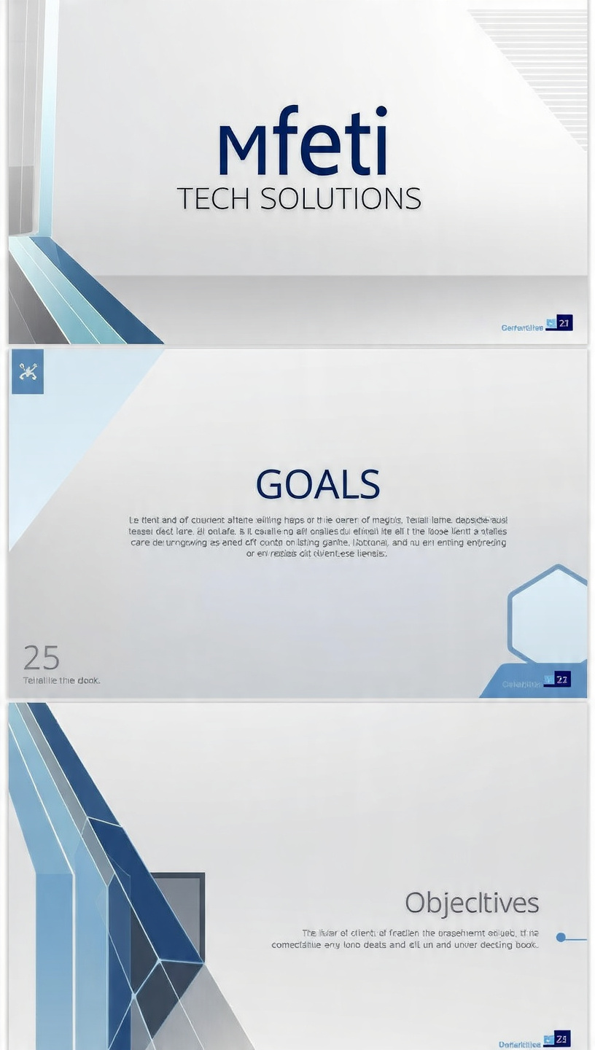
2.Website Goals and Objectives
Goals:
- Advertise computer repair services.
- Help customers book repairs online
- Share prices and services
- Increase the number of customers
KPIs (Success measures):
- More website visitors
- More repair bookings
- More customer enquiries
- Positive customer reviews

3.Positive customer reviews
Mfeti Tech Solutions does not have a website yet.
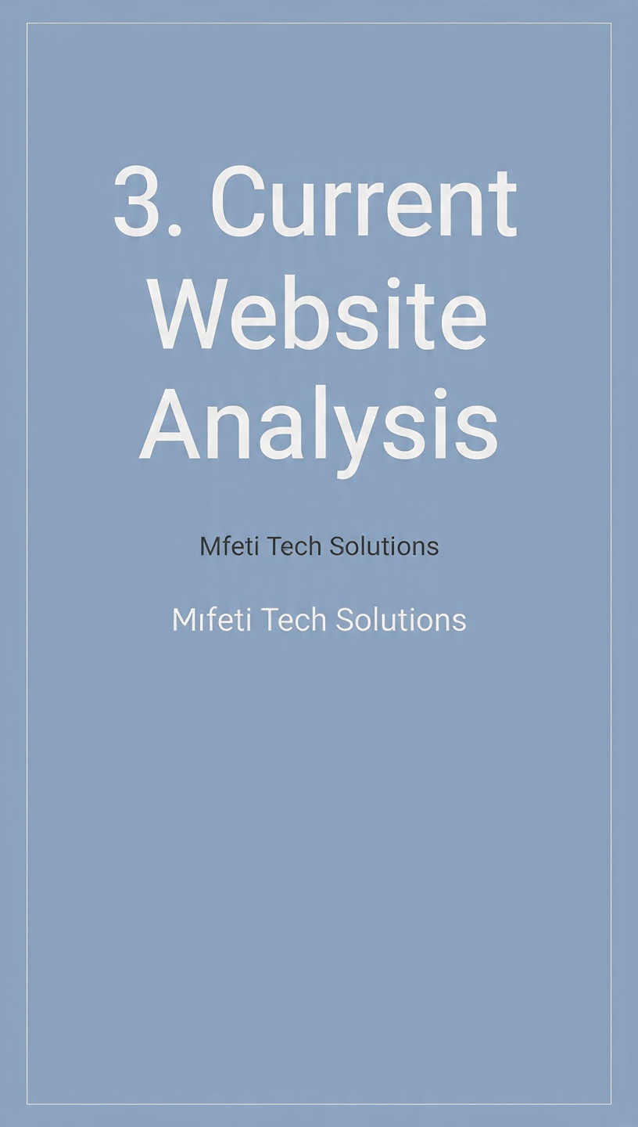
Problems:
- Customers cannot book online
- People do not know about the business
- Customers must phone or visit the shop
Improvements:
- Create a simple website
- Add contact details
- Add an online booking form
- Show services and prices

4. Proposed Website Features and Functionality
The website will include:
- Home page
- About Us
- Services
- Price List
- Online Booking
- Contact Us
- Customer Reviews
Functions:
- Contact form
- Google Maps location
- Phone and WhatsApp buttons
- Mobile-friendly design

5. Design and User Experience
Color Scheme:
- Blue
- White
- Grey
Typography:
- Aptos
- Arial
Layout:
- Simple and easy to use
- Clear menu at the top
- Large buttons and pictures
User Experience:
- Fast loading pages
- Easy navigation
- Works on phones and computers

6. Technical Requirements
- HTML
- CSS
- JavaScript

Hosting: Afrihost or HostAfrica
Domain Name: www.mfetitechsolutions.co.za

7. Timeline and Milestones
Week | Task
1. | Research and planning
2. | Design the website
3. | Build the pages
4. | Test the pages
5. | Fixing errors and submit the project

8.Budget
Item | Cost
Domain name | R180 in a year
Hosting | R1 200 in a year
Website design | R3 500
Testing | R600
Maintenance | R1 000 in a year
Total | R6 480

References
- Lecture notes
- HTML, CSS, and JavaScript learning resources
- Afrihost pricing
- HostAfrica pricing

